 | 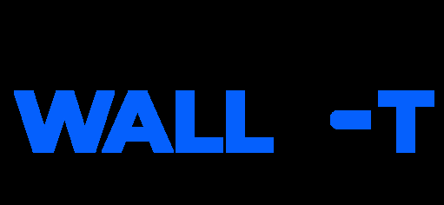
Data Flow Diagram
Date | 02 July 2026
Team ID
Project Name | Darshan Ease – Temple Darshan Ticket Booking System
Maximum Marks | 2 Marks

Data Flow Diagram
Create a Data Flow Diagram (DFD) to show how data moves through your system - between external entities, processes, and data stores. Use the symbol legend below as a guide.
DFD Symbol Legend
Symbol | Name | Description
Oval / Rounded shape | External Entity | A person, organization, or system outside the project that sends or receives data (e.g., Devotee, Temple Admin).
Rectangle with numbered header | Process | An activity that transforms incoming data into outgoing data (e.g., Validate User, Process Booking).
Rectangle (solid fill, no number) | Data Store | A place where data is held for later use (e.g., Booking Database, Ticket Database).
Labeled arrow | Data Flow | The movement of data between entities, processes, and data stores, labeled with what data is being passed.

Example
The diagram below illustrates how the symbols above come together to form a complete data flow diagram.
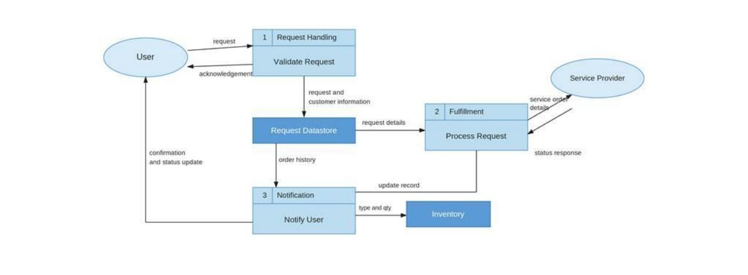

Data Flow Diagram – Darshan Ease
The diagram below shows how data flows between devotees, the temple admin, the core processes, and the data stores in the Darshan Ease system.
